Washington County Beekeepers Association  2018 Beekeeping Short Course  January 13 and 20, 2018  Registration Form | 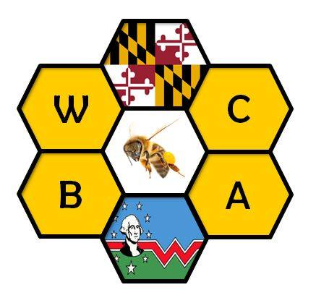

Participant Information
Name
Street Address
City, ST ZIP Code
Home Phone
Day Phone
E-Mail Address

Additional Participants Information
Name(s)
Phone
E-Mail Address(es)

Membership Status (Short Course registration fee includes one year membership in WCBA)

[ ] I am a new member.
[ ] I am a current member.
[ ] I do not wish to join WCBA at this time.

Short Course Fee

$40 per person, fee includes one copy of “Beekeeping Basics” course book

$20 for second person who is member of same family

Signature: __________________________________________________ Date: ________________

Make Checks Payable To:
Washington County Beekeepers Association
Mail to:
Rick Stephens
8520 Mountain Laurel Road
Boonsboro, MD 21713

